**School of magic program**

Related Learning Outcomes

**ULO1 – Explain the OO Principles**

The exercise demonstrated the use of enumerations

**ULO2 – Use OO Language and Library**

The exercise demonstrated the syntax for creating and using enumerations.

It also introduced the concept of indexers in C# which helps to access values in List-type fields within an object.

**ULO3 – Design, Develop and Test using an IDE**

This exercise demonstrated how to create new enumeration files with Xamarin studio. It also provides practice for unit testing using Xamarin Studio.

**ULO4 – Communicate using UML Diagrams**

This exercise introduced a new addition to the UML diagram for illustrating enumerations.

**ULO5 – Describe Elements of Good OO Design**

**Screenshots**

Code running

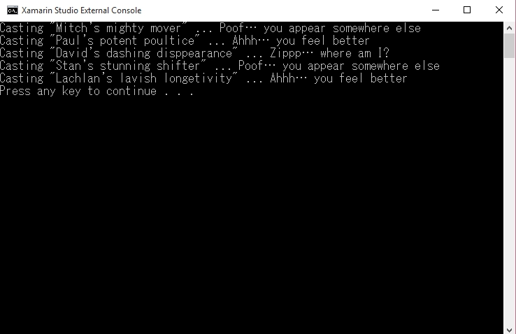

Running Tests

